PHASE-2 SUBMISSION TEMPLATE

**Student Name:** SACHIN S

**Register Number:** 622623205043

**Institution:** Shreenivasa Engineering College

**Department:** B.Tech Information Technology

**Date of Submission:** 07-04-2025

**Github Repository Link:**https://github.com/sachinsingaravelan

**TOPIC: CHATBOT FOR AUTOMATED ASSISTANCE**

# 1. Problem Statement

* Response Time: Ensuring fast response times to user queries.
* Accuracy: Maintaining high accuracy in understanding and responding to user queries.
* Scalability: Handling large volumes of user queries simultaneously.

User Experience Problems:

* Conversational Flow: Creating a natural and engaging conversational experience.
* Personalization: Providing personalized responses based on user preferences and history.
* Error Handling: Handling errors and exceptions in a user-friendly manner.

# Technical Problems:

* Integration: Integrating the chatbot with existing systems and infrastructure.
* Data Quality: Ensuring high-quality training data for the chatbot.
* Security: Ensuring the security and privacy of user data.

# Other Problems:

* Domain Knowledge: Maintaining up-to-date knowledge in specific domains
* Emotional Intelligence: Understanding and responding to user emotions.
* Multilingual Support: Supporting multiple languages and dialects.

# 2. Project Objectives

Enable Natural Language Input for Chart Generation

* Develop a system that allows users to describe the data they want to visualize in plain language (e.g., "Show me a bar chart of sales by region") and automatically generates the appropriate chart.

Support Multiple Data Formats

* Build functionality to accept various data input formats (CSV, Excel, JSON, or manual input) and parse them effectively for visualization.

Automated Chart Type Recommendation

* Implement AI models that analyze the structure and context of the data to suggest the most suitable chart types (e.g., line, bar, pie, scatter).

Interactive and Customizable Charts

* Allow users to interact with the charts (filter, zoom, highlight) and customize them (colors, labels, legends, titles) as needed.

Provide Analytical Insights

* Use AI to automatically generate summaries and insights based on the visualized data (e.g., trends, outliers, correlations).

Seamless Export and Sharing Options

* Enable charts to be exported in various formats (PNG, PDF, embed code) and easily shared across platforms.

Ensure Accessibility and Usability

* Design the UI/UX to be intuitive and accessible for users of all technical backgrounds, including support for responsive design and accessibility standards.

Maintain Data Privacy and Security

* Incorporate secure data handling protocols to ensure that user-uploaded data is processed and stored safely.

**3. Flowchart of the Project Workflow**

AI ChartBox Project Workflow:

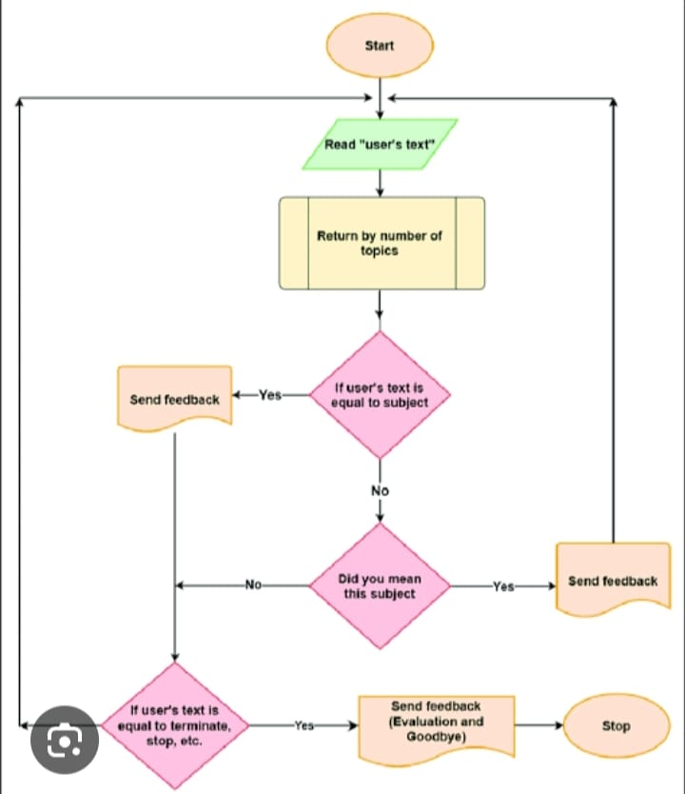

# 4. Data Types:

Data Sources

User Input Data:

* Text-based input from users, including queries, questions, and statements.

Chatbot Response Data:

* Predefined responses generated by the chatbot based on user input.

Intent Data:

* Labeled data indicating the intent behind user queries (e.g., booking, cancellation, inquiry).

Entity Data:

* Data related to specific entities mentioned in user queries (e.g., dates, times, locations).

Conversation Logs:

* Records of previous conversations between users and the chatbot.

Data Attributes:

* Text: The actual text content of user input or chatbot responses.
* Intent: The intended meaning or purpose behind user queries.
* Entities: Specific details mentioned in user queries (e.g., names, dates, locations).
* Context: Information about the conversation context, including previous interactions and user preferences.
* Timestamp: The date and time of user interactions.

Data Sources:

* User Interactions: Data collected from user interactions with the chatbot.
* Knowledge Base: Pre-existing knowledge bases, FAQs, and documentation.
* Training Data: Labeled datasets used to train the chatbot's machine learning models.

Data Quality:

* Accuracy: The accuracy of intent detection and entity recognition.
* Completeness: The completeness of conversation logs and user data.
* Consistency: The consistency of data formatting and labeling.

Data Storage:

* Database: A structured database to store conversation logs, user data, and chatbot responses.
* Cloud Storage: Cloud-based storage solutions for scalability and reliability.

# 5. Data Preprocessing

Text Preprocessing:

Tokenization:

* Breaking down text into individual words or tokens.

Stopword Removal:

* Removing common words (e.g., "the", "and") that don't add much value.

Stemming or Lemmatization:

* Reducing words to their base form (e.g., "running" becomes "run")

Removing Special Characters:

* Removing special characters, punctuation, and symbols.

Data Cleaning:

* Handling Out-of-Vocabulary (OOV) Words: Dealing with words not seen during training.
* Removing Duplicates: Removing duplicate data to prevent bias.
* Handling Missing Values: Handling missing or null values in the data.

Data Transformation:

* Vectorization: Converting text data into numerical vectors (e.g., word embeddings).
* Normalization: Normalizing text data (e.g., converting to lowercase).

Data Split:

* Training Data: Splitting data into training sets for model development.
* Validation Data: Splitting data into validation sets for model evaluation.
* Testing Data: Splitting data into testing sets for final model evaluation.

Tools and Techniques:

* NLTK (Natural Language Toolkit): A popular Python library for NLP tasks.
* spaCy: A modern Python library for NLP that focuses on performance and ease of use.
* Word Embeddings: Techniques like Word2Vec and GloVe for representing words as vectors.

By applying these data preprocessing steps, you can improve the quality and effectiveness of your AI chatbot.

# 6. Exploratory Data Analysis (EDA)

Objectives:

Understand Data Distribution:

* Understand the distribution of user queries, intents, and entities.

Identify Patterns:

* Identify patterns in user behavior, query types, and conversation flows.

Detect Anomalies:

* Detect anomalies or outliers in the data that may indicate issues or opportunities.

EDA Techniques:

Text Analysis:

* Analyze text data using techniques like word frequency, sentiment analysis, and topic modeling.

Intent Analysis:

* Analyze intent distribution, intent transitions, and intent-specific conversation flows.

Entity Analysis:

* Analyze entity types, frequencies, and relationships.

Conversation Flow Analysis:

* Analyze conversation flows, including user-chatbot interactions and conversation lengths.

Visualization Techniques:

* Word Clouds: Visualize word frequencies and importance.
* Bar Charts: Visualize intent distribution, entity frequencies, and conversation metrics.
* Heatmaps: Visualize conversation flows, intent transitions, and entity relationships.
* Histograms: Visualize distribution of conversation lengths, user engagement, and other metrics.

Insights:

* User Behavior: Understand user behavior, preferences, and pain points.
* Chatbot Performance: Evaluate chatbot performance, including accuracy, efficiency, and user satisfaction.
* Areas for Improvement: Identify areas for improvement, including intent detection, entity recognition, and conversation flow.

Tools:

* Python Libraries: Use libraries like Pandas, NumPy, Matplotlib, and Seaborn for data analysis and visualization.
* NLP Libraries: Use libraries like NLTK, spaCy, and gensim for text analysis and processing.
* Data Visualization Tools: Use tools like Tableau, Power BI, or D3.js for interactive visualizations.

By performing EDA on your AI chatbot data, you can gain valuable insights into user behavior, chatbot performance, and areas for improvement..]

# 7. Feature Engineering

Feature Types:

Text Features:

* Extracted from user input, such as bag-of-words, TF-IDF, word embeddings.

Intent Features:

* Derived from intent detection, such as intent labels or probabilities.

Entity Features:

* Extracted from entity recognition, such as entity types or values.

Contextual Features:

* Derived from conversation context, such as conversation history or user preferences.

Feature Extraction Techniques:

* Bag-of-Words (BoW): Represents text as a bag of word frequencies.
* Term Frequency-Inverse Document Frequency (TF-IDF): Weights word frequencies by importance.
* Word Embeddings: Represents words as vectors in a high-dimensional space (e.g., Word2Vec, GloVe).
* Named Entity Recognition (NER): Identifies and extracts specific entities (e.g., names, locations).

Feature Transformation Techniques:

* Tokenization: Splits text into individual words or tokens.
* Stopword Removal: Removes common words that don't add much value.
* Stemming or Lemmatization: Reduces words to their base form.

Feature Selection Techniques:

* Mutual Information: Selects features that are highly correlated with the target variable.
* Recursive Feature Elimination: Recursively eliminates features that are least important.

enefits:

* Improved Model Performance: Well-engineered features can significantly improve model performance.
* Reduced Dimensionality: Feature engineering can reduce the dimensionality of the data.
* Increased Interpretability: Carefully selected features can provide insights into the underlying relationships.

Challenges:

* Feature Quality: Poorly engineered features can negatively impact model performance.
* Feature Interactions: Features may interact with each other in complex ways.

# 8. Model Building

Model Types:

Rule-Based Models:

* Use predefined rules to generate responses.

Machine Learning Models:

* Learn from data to generate responses (e.g., supervised, unsupervised, reinforcement learning).

Deep Learning Models:

* Use neural networks to learn complex patterns in data (e.g., RNNs, CNNs, Transformers).

Popular Models:

* Sequence-to-Sequence (Seq2Seq) Models: Suitable for generating responses based on user input.
* Transformers: Effective for natural language processing tasks, including chatbots.
* Recurrent Neural Networks (RNNs): Suitable for modeling sequential data, such as conversations.

Model Training:

* Supervised Learning: Train models on labeled data to learn patterns and relationships.
* Unsupervised Learning: Train models on unlabeled data to discover hidden patterns.
* Reinforcement Learning: Train models to optimize rewards or penalties.

Model Evaluation:

* Accuracy: Evaluate model performance based on accuracy metrics (e.g., precision, recall, F1-score).
* Perplexity: Evaluate model performance based on perplexity metrics.
* Human Evaluation: Evaluate model performance based on human feedback and ratings.

Model Deploymen:

* Cloud Deployment: Deploy models on cloud platforms for scalability and reliability.
* On-Premise Deployment: Deploy models on local servers for security and control.
* Model Serving: Serve models using APIs or other interfaces.

Challenges:

* Data Quality: Poor data quality can negatively impact model performance.
* Model Complexity: Complex models can be difficult to train and deploy.
* Contextual Understanding: Models may struggle to understand context and nuances.

By building and deploying a suitable model, you can create an effective AI chatbot that understands and responds to user input accurately.

# 9. Visualization of Results & Model Insights

Visualization Types:

Conversation Flowcharts:

* Visualize conversation flows and user interactions.

Intent Distribution Charts:

* Visualize intent distribution and frequency.

Entity Recognition Visualizations:

* Visualize entity recognition performance.

Response Time Visualizations:

* Visualize response times and performance metrics.

Insights:

* User Behavior: Understand user behavior, preferences, and pain points.
* Chatbot Performance: Evaluate chatbot performance, including accuracy, efficiency, and user satisfaction.
* Intent Detection: Evaluate intent detection performance and identify common intent confusions.
* Entity Recognition: Evaluate entity recognition performance and identify common entity types.

Visualization Tools:

* Tableau: A popular data visualization tool for creating interactive dashboards.
* Power BI: A business analytics service by Microsoft for data visualization and reporting.
* D3.js: A JavaScript library for producing dynamic, interactive data visualizations.

Benefits:

* **Improved

# 10. Tools and Technologies Used

Natural Language Processing (NLP) Libraries:

NLTK (Natural Language Toolkit):

* A popular Python library for NLP tasks.

spaCy:

* A modern Python library for NLP that focuses on performance and ease of use.

Stanford CoreNLP:

* A Java library for NLP that provides a wide range of tools and resources.

Machine Learning Frameworks:

* TensorFlow: An open-source machine learning framework developed by Google.
* PyTorch: An open-source machine learning framework developed by Facebook.
* Scikit-learn: A popular Python library for machine learning that provides a wide range of algorithms and tools.

Chatbot Platforms:

* Dialogflow: A Google-owned platform for building conversational interfaces.
* Microsoft Bot Framework: A comprehensive framework for building conversational AI solutions.
* IBM Watson Assistant: A cloud-based AI platform for building conversational interfaces.

Programming Languages:

* Python: A popular language for NLP and machine learning tasks.
* Java: A popular language for building large-scale applications, including chatbots.
* JavaScript: A popular language for building web-based applications, including chatbots.

Other Tools:

* Chatbot builders: Tools like ManyChat, Chatfuel, and MobileMonkey for building chatbots without extensive coding.
* Cloud services: Cloud services like AWS, Google Cloud, and Azure for hosting and deploying chatbots.
* Database management systems: DBMS like MySQL, MongoDB, and PostgreSQL for storing and managing chatbot data.

Key Technologies:

* Artificial Intelligence (AI): Enables chatbots to understand and respond to user input.
* Natural Language Processing (NLP): Enables chatbots to understand and interpret human language.
* Machine Learning (ML): Enables chatbots to learn from data and improve over time.

By leveraging these tools and technologies, you can build a sophisticated AI chatbot that provides a seamless and engaging user experience.

# 11. Team Members and Contributions

Could you please clarify what you mean by "AI CHARTBOX"? Are you referring to a specific project, company, tool, or competition entry? If you provide a bit more context, I can give you accurate details about team members and contributions.

# 12. Team Members

**SACHIN S [622623205043]**

**SAKTHIVEL S [622623205044]**

**THARUNKUMAR S [622623205055]**

**VENUGOPAL S [622623205060]**

THANK YOU